NOTES 2A.1- Graphing Absolute Value Functions

In this unit you will learn to:
- graph absolute value transformations
- give a verbal description of the transformations
- write equations from descriptions and graphs
- List all relevant information about a transformed graph
- Write a function notation description

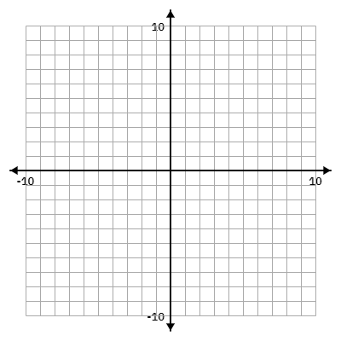
Notes:

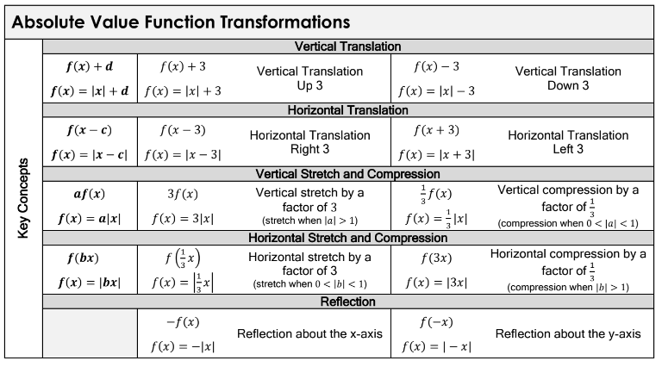

Example 1: Given an equation, graph, and provide all information.

Equation: $f(x)= -2|x+3|$ | Domain:
 | Range:
X-int:

Y-int:

 | Vertex:
 | Max/Min:
Verbal Description:

Function Notation Description:

Example 2: Given an equation, graph, and provide all information.

Equation: $f(x)= |x-3|-2$ | Domain:
 | Range:
X-int:

Y-int:

 | Vertex:
 | Max/Min:
Verbal Description:

Function Notation Description:
Example 3: Given an equation, graph, and provide all information.

Equation: $f(x)= \frac{1}{2}|x+3|+1$ | Domain:
 | Range:
X-int:

Y-int:

 | Vertex:
 | Max/Min:
Verbal Description:

Function Notation Description:

Example 4: Given the transformed graph, write the equation, and provide all information.

Equation: | Domain:
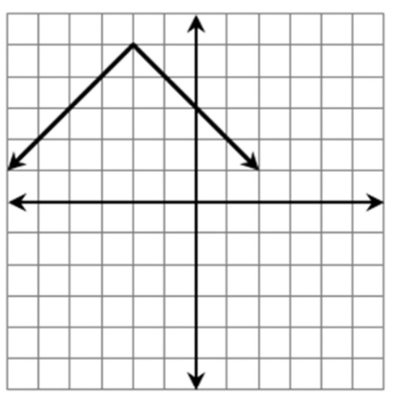 | Range:
X-int:

Y-int:

 | Vertex:
 | Max/Min:
Verbal Description:

Function Notation Description:

Example 5: Given the transformed graph, write the equation, and provide all information.

Equation: | Domain:
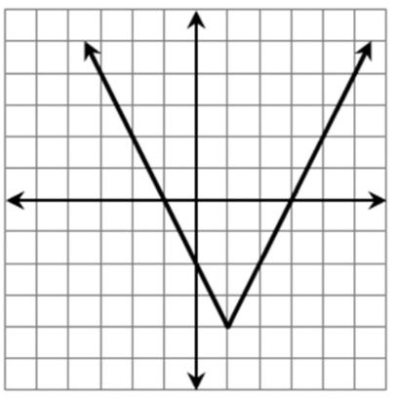 | Range:
X-int:

Y-int:

 | Vertex:
 | Max/Min:
Verbal Description:

Function Notation Description:

Example 6: Given the transformed graph, write the equation, and provide all information.

Equation: | Domain:
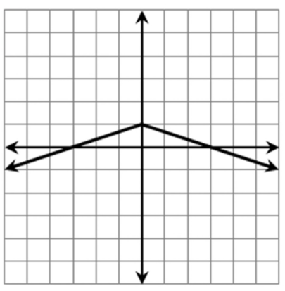 | Range:
X-int:

Y-int:

 | Vertex:
 | Max/Min:
Verbal Description:

Function Notation Description:

Example 7: Given the verbal description, write the equation, graph, and provide all information.
Equation: | Domain:
 | Range:
X-int:

Y-int:

 | Vertex:
 | Max/Min:
Verbal Description: The function is reflected about the x-axis, vertically compressed, by a factor of $\frac{1}{3}$ and then shifted left 4 units.
Function Notation Description:

Example 8: Given the verbal description, write the equation, graph, and provide all information.
Equation: | Domain:
 | Range:
X-int:

Y-int:

 | Vertex:
 | Max/Min:
Verbal Description: The function is stretched horizontally by a factor of 2, then translated 10 units down.
Function Notation Description:

